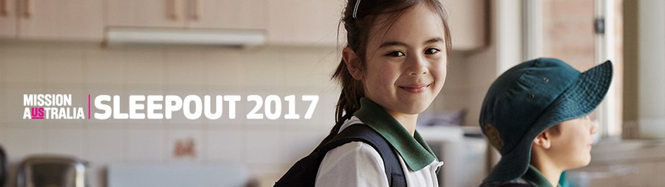

Dear <Salutation>,

I’m sleeping out to help end homelessness. Will you sponsor me?

This year I’m taking part in the Mission Australia Sleepout to raise funds and awareness for Australians experiencing homelessness, and I’d really appreciate your support.

Mission Australia is a non-denominational Christian charity that has been helping Australians in need move towards independence for more than 155 years. Last financial year, they cared for 131,015 people nationwide by combatting homelessness, assisting disadvantaged families and children, addressing mental health issues, and much more.

Right now in Australia, domestic violence, health problems, job loss and lack of affordable housing are forcing desperate families into crisis shelters, motels, cars and other temporary accommodation. I am determined to help them. You can help them too.

If you would like to support the 105,000¹ Australians who are homeless on any given night, you can sponsor me through my online fundraising page. I’m aiming to raise $<XX>.

<link to fundraising page>

Did you know that just $22 can buy a set of single bed sheets; $112 can purchase a desk, chair and reading lamp to help a child study; and $331 can provide a young person with housing for a month at one of Mission Australia’s youth services?

All donations $2 and above are tax deductible, and you’ll be sent a receipt immediately after you donate. Making a difference couldn’t be easier!

Please follow Mission Australia on social media to find out about other events you can get involved in to help vulnerable people pursue long-term, lasting change in their lives.

Thanks for your help!

<Your name>

